**IOT_PHASE4:** **PUBLIC TRANSPORT OPTIMIZATION**

**TEAM MEMBER:** MOHAMMED JASIR ALI S A (822721106305)

**Project Title:** Public Transport Optimization

**Project Description:** This project involves integrating IOT Sensors into public transportation vehicles to monitor ridership, track locations, and predict perfect arrival times. The goal is to provide real -time transit information to the public through a public platform, enhancing the efficiency and quality of public transportation services. This project includes defining Objectives, designing the IOT sensor system, developing the real-time transit information platform, and integrating them using IOT technology and python.

**WORKFLOW:**

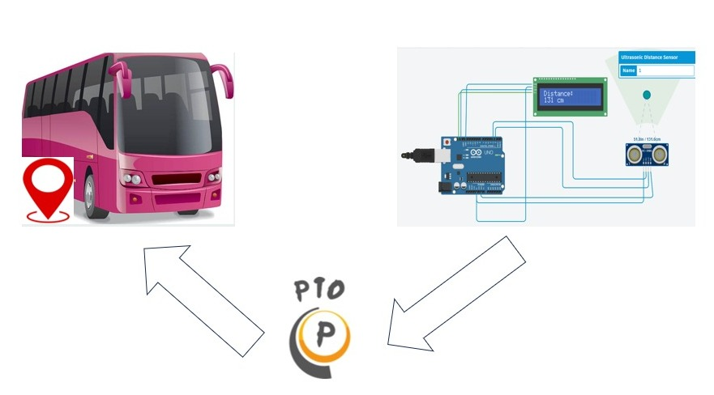

**MOTIVE FOR AN PTO APPLICATION:**

Location tracking for a bus using an app refers to the capability of monitoring and displaying the real-time geographical position of a bus through a mobile application. This technology allows users to track a bus's current location, estimated arrival times, and other relevant information, enhancing public transportation efficiency and providing passengers with the ability to plan their journeys more effectively.

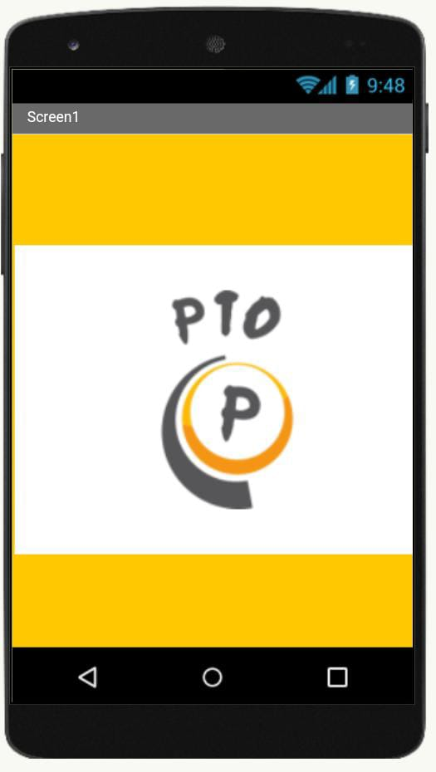 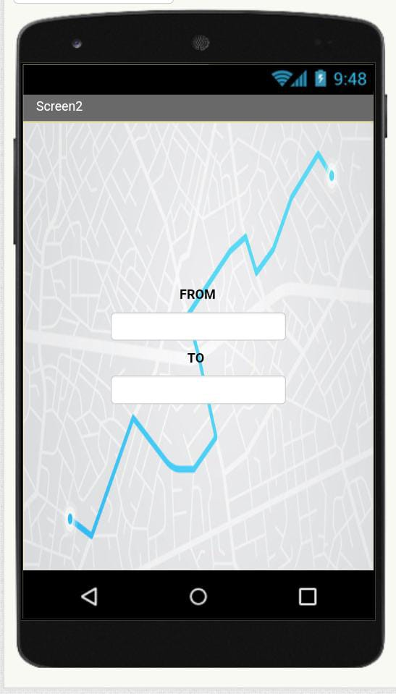

While bus location tracking apps offer numerous advantages in terms of improving public transportation systems, addressing the potential disadvantages is crucial to ensure widespread adoption and passenger satisfaction.

**MERITS:**

**Better Route Planning:** The app provides information on bus schedules, estimated arrival times, and alternative routes, helping passengers plan their journeys more effectively.

**Improved Passenger Experience:** Passengers can easily track the real-time location of buses, reducing uncertainty and wait times, leading to a more convenient and efficient public transportation experience.

**Enhanced Safety:** Real-time tracking enables quicker response to emergencies or accidents, ensuring the safety of passengers and bus drivers.

**DEMERITES:**

**Accessibility:** Not all passengers may have access to smartphones or the ability to use such apps, potentially creating a digital divide.

**Implementation Costs:** Developing and maintaining a bus location tracking app and associated infrastructure can be costly for transit agencies.

**Technical Issues:** Connectivity problems or software glitches can disrupt the accuracy of location tracking, leading to potential passenger frustration.

**HOW IS GOING TO BE WORK?**

